COMMONWELTH OF MASSACHUSETTS

, SS | Civil Action No.:

Claire Ireland and Simon Ireland,  Plaintiff  vs.  Fenwick Group and Panera Bread Company,  Defendant | )  )  )  )  )  )  )  )  )  )  )  ) | KEEPER OF RECORDS  NOTICE OF TAKING DEPOSITION

TO: | James T. McCarthy, Esquire  Gelman, Gelman, Wiskow & McCarthy  One Broadway, Suite 401  Elmwood Park, NJ 07407 | James T. McCarthy, Esquire  Gelman, Gelman, Wiskow & McCarthy  One Broadway, Suite 401  Elmwood Park, NJ 07407

Please take notice that commencing at 10:00 a.m. on at Law Offices of Michael J. Rossignol, 400 Atrium Drive, Fifth Floor PO Box 6745, Somerset, NJ 08875-6745 the Defendant in this action by its attorney will take the deposition upon oral examination of the KEEPER OF RECORDS, Advanced Imaging Associates Sterling Plaza, Medical Records, Route 517 South , Franklin, NJ 07416 pursuant to Rule 30 of the Massachusetts Rules of Civil Procedure before a Notary Public, in and for the Commonwealth of Massachusetts, or before some other officer authorized by law to administer oaths. The oral examination will continue from day to day until completed. You are invited to attend and cross-examine.

Pursuant to M.G.L. Ch. 111, S. 70, as Amended by Chapter 158 of the Acts of 1990, this subpoena may be performed by mailing a certified copy on or before the date specified above to Axiom Requisition Copy Service, 447 North Canal Road, Lansing, MI 48917. YOU NEED NOT APPEAR IN PERSON. The Deponent is requested to forward the following: SEE ATTACHED SCHEDULE "A".
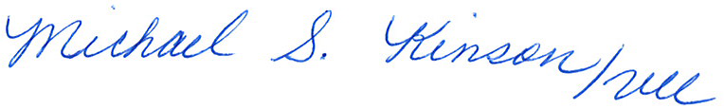

_______________________________________
Neil DeCostanza, Esquire
Law Offices of Michael J. Rossignol
400 Atrium Drive, Fifth Floor PO Box 6745
Somerset, NJ 08875-6745
Tel.: (732) 805-2900
Dated:

Order No. 01-17046-001

